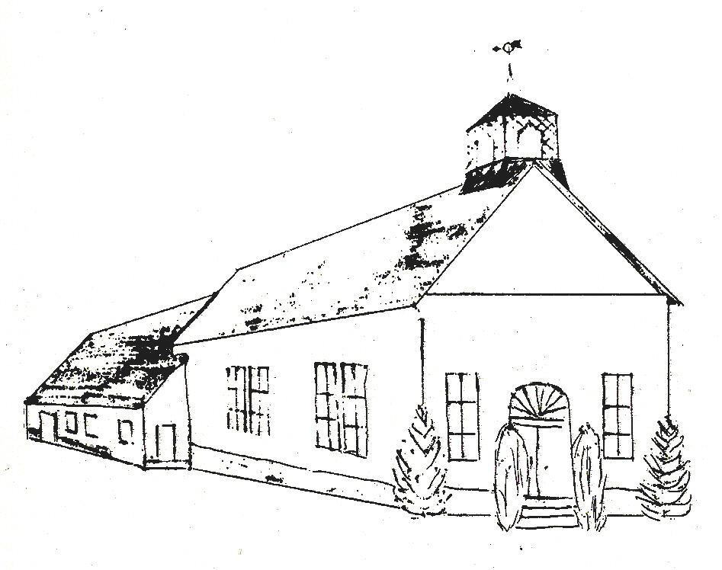Constitution

# Little Falls

***Baptist Church***

## Gorham, Maine

Dedication

This revised Constitution is presented to the church in memory of Mr. & Mrs. Gordon Corkum. The Corkum's joined the church February 13, 1938, and were active members and strong Christian supporters of the church for many years.

Mr. Corkum served as parsonage agent from 1942 to 1945, and as a deacon from 1956 to 1960. Mrs. Corkum (Lena) served on the Board of Deaconesses during this period, and both were elected Honorary Members of their Boards for life in 1960.

The Corkum's served in other positions and filled many needs during their long membership. Among these were serving as delegates to the Cumberland County Baptist Association, and in positions on the nomination committee. Gordon was instrumental in securing the Bell from the old Frederick Robie School (now the Legion Hall) and having our belfry erected. The Bell was dedicated on November 20, 1960.

Their service is an example to us all, and to them we offer the ancient prayer “well done, thou good and faithful servant”.

Signed: The Advisory Board

Barbara Dyke

Joanne Edwards

Effie Randall

Derwood Smith

Ralph Willis, Chairman

Preface

In late 1975, the need for constitutional revision was expressed by members of the church. During the spring of 1976, a committee consisting of Mrs. Barbara Dyke, Mrs, Joanne Edwards, Pastor Gifford, Mrs. Effie Randall, Mr. Derwood Smith, Mr. Ronald Summy, and chairman Ralph Willis met and discussed the constitution in some depth. Changes for clarity were made in several sections, particular in listing the duties of various groups and officers. Changes in entire content and function were made in separationg the Board of Trustees from the Feeaconate Board. These changes are intended as guidelines, not as immovable boundaries, and should be used flexibly when future needs or conflicts arise.

Ralph B. Willis, chairman

Advisory Board

2

Constitution

Together with

# The Covenant

### Articles of Faith

#### Historical Sketch

##### Of the

***Little Falls Baptist Church***

*In*

*Gorham, Maine*

*Post Office: South Windham, Maine*

***Rivision Adopted on***

***January 24, 1976***

## At the Annual Meeting of the Church

*3*

Our Covenant

Having been led as we believe by the Spirit of God to receive the Lord Jesus Christ as our Saviour and of profession of our faith having been baptized in the name of the Father and of the Son and of the Holy Spirit, we do now in the presence of God, angels, and this assembly most solemnly and joyfully enter into covenant with one another as one body in Christ.

We promise by the aid of the Holy Spirit to forsake the paths of sin and to walk in the ways of holiness all the days of our lives. With this view we engage to strive together for the advancement of this church in knowledge, holiness, and comfort; to promote its prosperity and spirituality; to sustain its worship, ordinances, discipline and doctrines; to contribute cheerfully and regularly to the support of the ministry, the expenses of the church, the relief of the poor, and the spread of the Gospel throughout all nations.

We also engage to maintain family and secret devotions; to educate our children religiously; to seek the salvation of our kindred and acquaintances; to walk circumspectly in the world; to be just in our dealings, faithful in our engagements, and exemplary in our deportment; to avoid all tattling, backbiting, and excessive anger, to abstain from the sale and use of intoxicating liquors as a beverage and to be zealous in our efforts to advance the kingdom of our saviour.

We further engage to walk together in Christian love and watchfulness, giving and receiving admonition with meekness and affection; to remember each other in prayer; to aid each other in sickness and distress; to cultivate Christian sympathy in feeling and courtesy in speech; to be slow to take offense but always ready for reconciliation; mindful of the rules of our Saviour to secure it without delay. We moreover engage that when we remove from this place well as soon as possible unite with some other churches where we can carry out the spirit of this covenant and the principles of God’s Words.

4

Our Articles of Faith

I. The Old and New Testament Scriptures were written by men divinely inspired and is the only sufficient and perfect rule of faith and practice.

II. There is one God and only one, who is self-existent, eternal and infinite in every excellence and who has revealed Himself as Father, Son, and Holy Spirit, the same in essence through distinct in personality.

III. Man was created innocent. By disobedience of the command of God he fell, thereby losing his innocence, becoming subject to death and to the eternal displeasure of god.

IV. Jesus Christ, the Son of God and the Son of Man came into the world to save men from the guilt and condemnation of sin, offering His blood as an atonement and making it available to all who exercise faith in Him.

V. The human means by which this result is secured is repentance and faith whereby we turn unto God in sincere contrition and accept Jesus Christ as our all – sufficient Saviour.

VI. God has His purposes of Grace in the Salvation of men. These purposes are made effectual in the giving of His Son and in the constraining and regenerating influence of the Holy Spirit upon all whom sincerely believe on Christ. But these purposes do not contravene the freedom of man’s will nor render inoperative the proclamation of the Gospel to all.

VII. Nothing can separate true believers from the love of God; but they are “kept by the power of God through faith unto salvation”, the sure proof of this being their patient continuance and progress in righteousness and true holiness.

5

Our Articles of Faith

VIII. The ordinances of the Gospel are baptism and the Lord’s Supper. Baptism is the immersion in water of a believer in Christ “in the name of the Father, the Son, and the Holy Spirit", and symbolizes the fact of regeneration. It symbolizes also the fact of Christ’s death and resurrection, and also the believer’s death to sin and resurrection to the new life in Christ Jesus. The Lord’s Supper is the commemoration of His dying love and symbolizes the fact that the believer is continually fed and nourished by Christ in spiritual things; in this observance it is to be placed after baptism according to its symbolic and historic order and as required by the teaching of the New Testament.

IX. The Church spiritual includes the whole company of believers of whatever name, age, or country, and is known only to the eye of God. The Church formal is a company of baptized believers observing the forms, ordinances, and principles laid down in the New Testament.

X. The first day of the week is to be observed as the Lord’s Day of Christian Sabbath.

XI. Civil government is of divine appointment for the interests and good order of human society, and magistrates are to be prayed for, conscientiously honored and obeyed except only in things opposed to the will of our Lord Jesus Christ who is the only Lord of the conscience and the Prince of the Kings of the earth.

XII. Jesus Christ is to come again, to judge the nations and fill the earth with His glory and power.

XIII. There will be a resurrection of the Just and the unjust: The Just for blessedness and reward: the unjust for judgment and eternal doom.

6

Our History

Introduction

This is a historical sketch of our Church. Information has been gleaned from an anonymous history, and has been rewritten and summarized.

The list of the pastors came from the clerk’s record book. It is hoped that this short article will give you an idea of the background of the Church.

The First Baptists in Maine

The First Baptist Church in what is now Maine was established in Kittery. For preaching doctrine different than the Congregationalist doctrine, the preacher was fined ten pounds and told to preach no more. The pastor and his congregation then moved to South Carolina.

Some years later, in 1780, John and William Cotton and William Thomes were converted to the Baptist faith. Since there was no meeting place, these men placed an article in the Gorham. Massachusetts (Maine) Town Warrant that year, to see id the Town would allow them to use the regular meeting house (Congregational) for their services. The answer “No”. Upon the hearing of this answer, Deacon Austin Alden said “God be praised, and the Devil is defeated this time”. However, the Baptists increased in number and the next year (1781), a church was organized at Fort Hill. They may have met in the Old Fort. This church ordained Samuel Thomes as elder in 1786. At the

7

same time it also ordained two deacons: Andrew Cobb and George Hamblen.

Baptists at Fort Hill - Gorham

Since the Congregationalist Church was a State Church, the Baptists were taxed to support the Congregational minister. Because the Baptists believed the Church and State should be separate, they refused to pay the tax. A list of 25 names was presented to the Selectmen, as being members be exempted from paying the tax to support the Congregational minister. The Town voted, providing that the Baptists presented a certificate of membership for each member signed by the pastor.

In 1781, a list of 60 members was presented to the selectmen; however, the pastor would sign only the certificates of those who attended regularly. This also occurred in 1787. Several times the Church asked to have the pastor’s tax abated, but to no avail.

A meetinghouse was built sometime prior to Jun 4, 1798. The town records reveal that the Town Meeting was held in the Church that year until the schoolhouse could be erected at the corner.

On June 10, 1801, the society seemed somewhat perplexed about the singing at the worship services. Apparently not many could sing well. The record says, “Those who are singers may sing and as many as can join so carry on the Worship of God”.

In 1839 the church building at Fort Hill was enlarged and furnished with forty-two pews. It was dedicated on January 1, 1840. Regular meetings were held until 1846 when members

8

either died or moved away. It was dropped form the Convention.

Since there was no preaching after that, the State Legislature allowed Fred Gilkey to sell the building. It was sold at public auction February 21, 1877, for fifty dollars to Gerry Rounds. Mr. Rounds tore it down and used the lumber to build a house on Preble Street.

The Little Falls Baptist Church

Through the preaching ministry of Elder Clement Phinney, a Free Baptist Church was organized at Mallison Falls in 1827. A meetinghouse was built on the Windham side of the Presumpscott River. Evidently the Church did not prosper very well. In 1835 William Bacon got the members together. He was elected clerk and remained clerk until 1892. Progress was slow until 1839. A revival led by Elder James Buzzell, M.D., led to a large addition of new members.

A new building was built on the present site of the Church in 1841. This building burned in 1866 and Salomen Cloudman built a new one. This new building is the main part of the present church. The vestry was added in the 1920’s and sold in 1966. In June 1966, ground was broken at 12 Mosher Road for a new parsonage, and the dedication was held on December 20, 1967.

The Church has been known by many names. It was organized as the First Baptist Church (Free Will). In 1859 the name was changed to the Little Falls Church. For many years it has been popularly known as the South Windham Baptist Church. Its present name is Little Falls Baptist Church in Gorham, Maine,

9

Mailing address: South Windham, Maine.

In 1911 it was voted that the Little Falls Baptist Church cease to exist and that a Methodist Episcopal Church be organized. This was apparently do to a lack of Baptists. However, the Baptists continued to have their annual meetings and carried on their organization. The Methodists used the building, which remained Baptist property. In 1920, after much controversy over a period of nine years, an arbitration committee appointed by the Executive Committee of the Interdenominational Commission of Maine, recommded the building be turned back to the Baptists and the Methodist Organization cease.

From 1920 until the 1940, there was a long period of general growth. The early thirties witnessed large numbers of baptisms under Evangelist Walter M. Colby. The peak of growth came late during the thirties under Rev. Colby’s pastoral leadership. The membership was above two hundred.

Missionary interest has risen a great deal. We have even been fortunate to have Missionaries from our own church. Al and Beverly Rowe and family have been commissioned to serve with the Wycliffe Associates in Brazil. They served from January 1969 until August 1972, came home for a year’s leave of absence, then returned to Brazil in July 1973.

Though it is well to look behind, it is better to look ahead for a greater vision. Paul suggests this when he says, “Forgetting those things that are behind, and looking forward to the things that are ahead, let us press for the prize of the high calling of God in Christ Jesus.”

10

Former Pastors of this Church

In its early days, the church was supplied by travelling preachers. The first settled pastor, Elder James Buzzell, M.D., came in 1839; and he remained until 1844. He was followed by the Reverends:

Amos Ridlon David Newell

Benjamin S. Mason William F. Eaton

O. P. Smith William J. Twort

Fairfield Elder Maddox

J. Franklin E. C. Cook

E. C. Harmon William A. Tucker

LeRoy S. Beane George Gray

A. F. Cox William Fultz

Former Pastors (1919-1976)

Rev. A. A. Walsh – 1919-1921

Dr. Charles L Woodworth (Interim) – 1921-1923

Rev. George W. Collins – 1923 –1924

Rev. Margaret Kock – 1926 1927 (?)

Rev. Fred A. Groesbeck – 1927- 1930

Rev. Gath Kock – 1930 (3 months)

Rev. E. A. Kelley – 1931 – 1932

Dr Charles W. Woodworth – 1932 – 1934 ( Interim)

Rev. Walter M. Colby - 1934 - 1940

Rev. Gerald Beals – 1940 - 1945

Rev. J. A. Beyea – 1945 - 1951

Rev. Walter M. Colby – 1951 - 1957

Rev. T. Lawrence Gilbert, Jr. – 1957 - 1961

Rev. Louis George – 1961 - 1965

Rev. David Janzen – 1965 - 1969

Rev. George Gifford – 1969 – 1976

11

Article VI – Meetings

Section 1 _ The Lord’s Day

The Church shall meet regularly on each Lord’s Day, morning and evening, for public worship. The Lord’s Supper shall be observed on the first Sunday of every month. A Sunday Church School shall be held each Lord’s Day unless otherwise voted by the Church.

# Section 2 – The Midweek Service

At least once each week the Church shall meet for prayer, praise, and Bible Study.

# Section 3 – Quarterly Business Meetings

The quarterly business meetings of this Church shall be conducted on the first Saturday of April, the fourth Saturday of June, and the first Saturday of October. The alternate date in case of inclement weather shall be one week later.

# Section 4 – Annual Business Meeting

The Annual business meeting of this church shall be held on the fourth Saturday of January each year. The alternate date in case of inclement weather shall be one week later.

The purpose of the meeting shall be to elect officers; receive written reports from all committees, organizations, and departments of the Church; and for consideration of such business as may come before it. The election shall be written ballot or as the present shall decide. The meeting shall

26

**Section 4 – Annual Business Meeting – cont.**

Be conducted according to Robert’s Rules of Order. The order of business shall be as follows:

1. Reading of the Scripture and Prayer.

2. Reading of the minutes of the last annual meeting.

3. Annual reports of officers and committees.

4. Reports of Church organizations.

5. Election of officers and committees as provided in the

Bylaws.

6. Miscellaneous business.

7. Adjournment.

# Section 5 – Annual Roll Call

There shall be an annual roll call when it is expected that every member will report either in person, by friend, or by letter. The particular day and order of the meeting shall be under the direction of the Standing Committee.

# Section 6 – Special Meetings

The Standing Committee or the Pastor may call special meetings of the Church.

27

Article VII – General

Section 1 – Conducting Business

At any regular service of the Church any business pertaining to the reception or dismissal of members, or the special interest and welfare of the Church may be transacted provided not less than the ordinary quorum of members ( Art. VII, Sect. 2) are present. Any matter of important business such as the calling or dismissal of a Pastor, the sale or purchase of property, the placing of a mortgage or assumption of financial responsibilities may be legally done only when notice of said meeting specifying the matters to be considered shall be posted on the outer door or the edifice at least seven days before the day set for the meeting and announced at one Sunday morning preaching service. Only those eighteen years of age and more shall be entitled to vote.

# Section 2 – Quorums

At all business meetings seven shall constitute a quorum.

# Section 3 – Fiscal Year of the Church

The fiscal year of the Church shall begin on the first of January and all accounts of the Church shall be made up to that time. All organizations within the Church being part of the Church life shall therefore be responsible to the Church and shall keep correct records of their work and funds in books, and shall make reports whenever so directed by the Church and also at the annual meeting.

28

# Section 4 – Regarding the Will of the Church

All committees, officers and organizations of the Church shall carry out the will of the Church on any given matter duly expressed by its vote.

## THE END

29